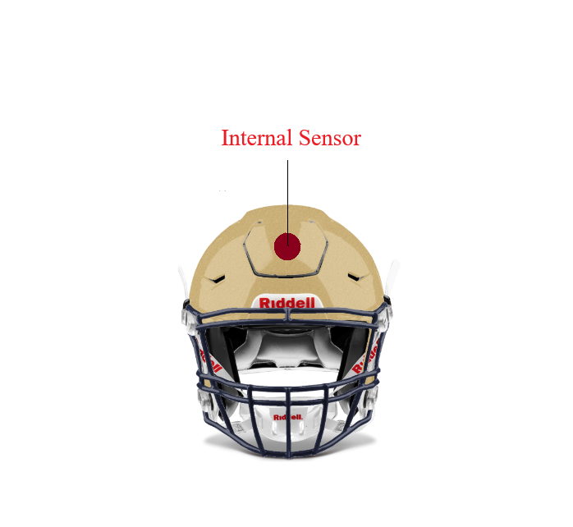

| **Features** | **Specifications** |
| --- | --- |
| **Impact Measurement** | *Up to 200 G Force* |
| **Wireless Connection** | *Bluetooth* |
| **Connection Range** | *At least 100 meters* |
| **Battery** | *Rechargeable* |